JAVA PROGRAMMING LAB ASSIGNMENT
Experiment 1: Advantages of Java and Comparison with C/C++
Aim
To study the advantages of Java and compare it with C/C++.
Theory
Five Advantages of Java
- Platform Independent
  - Java programs run on any operating system using the Java Virtual Machine (JVM).
- Object-Oriented
  - Java follows object-oriented programming concepts such as encapsulation, inheritance, polymorphism, and abstraction.
- Secure
  - Java provides built-in security features like bytecode verification, exception handling, and no direct pointer access.
- Robust
  - Java has automatic memory management (Garbage Collection) and strong exception handling mechanisms.
- Multithreading
  - Java supports multiple threads, allowing several tasks to execute simultaneously.

Comparison between Java and C/C++
Feature | Java | C/C++
Platform | Platform Independent | Platform Dependent
Compilation | Compiles to Bytecode | Compiles to Machine Code
Memory Management | Automatic Garbage Collection | Manual Memory Management
Pointers | Not Supported | Supported
Multiple Inheritance | Through Interfaces | Supported in C++
Security | Highly Secure | Less Secure
Execution | JVM Required | Runs Directly
Object-Oriented | Fully Object-Oriented | C is Procedural, C++ is Hybrid

Result
Thus, the advantages of Java were studied and Java was compared with C/C++.

Experiment 2: Install Java successfully and submit a screenshot along with the output of the Hello World program.
Aim
To install Java Development Kit (JDK) and execute the Hello World program.
Software Required
- JDK
- Command Prompt
- Text Editor (Notepad/VS Code)
Procedure
- Download and install JDK.
- Set the JAVA_HOME and PATH environment variables.
- Verify installation using:
- java -version
javac -version
- Create a Java program named Hello.java.
- Compile the program:
javac Hello.java
- Execute the program:
java Hello
Program
class Hello
{
public static void main(String args[])
{
System.out.println("Hello World");
}
}
Output
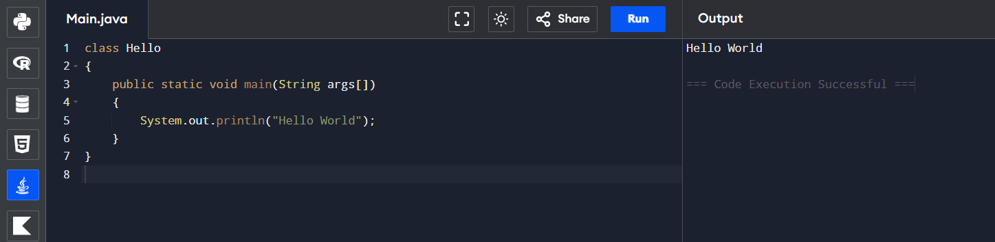
Result
Thus, Java was installed successfully and the Hello World program was executed.

Experiment 3: Write programs demonstrating variable scope and lifetime.
Aim
To demonstrate local, instance, and static variables in Java.
Theory
- Local Variable: Declared inside a method and exists only during method execution.
- Instance Variable: Declared inside a class but outside methods. Each object has its own copy.
- Static Variable: Shared among all objects and exists throughout the program execution.
Program 1: Local Variable
class LocalDemo
{
public static void main(String args[])
{
int x = 100;
System.out.println("Local Variable = " + x);
}
}
Output
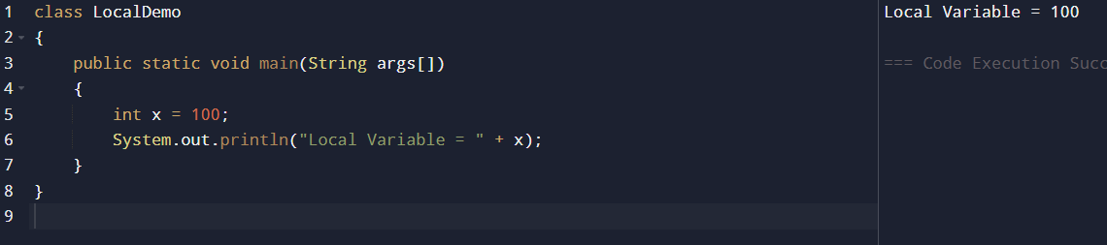
Program 2: Instance Variable
class InstanceDemo
{
int x = 50;
public static void main(String args[])
{
InstanceDemo obj = new InstanceDemo();
System.out.println("Instance Variable = " + obj.x);
}
}
Output
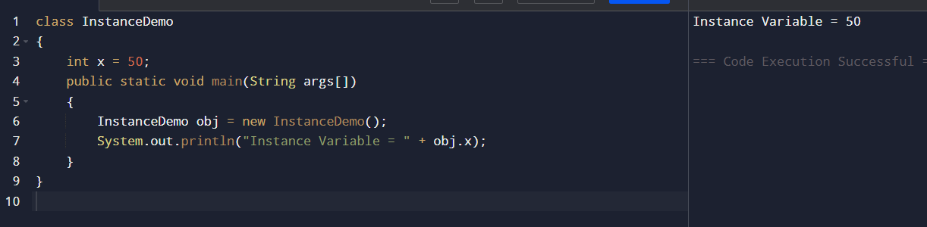
Program 3: Static Variable
class StaticDemo
{
static int x = 200;
public static void main(String args[])
{
System.out.println("Static Variable = " + x);
}
}
Output
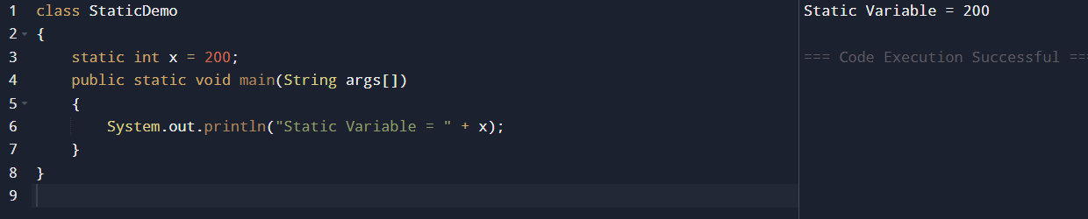

Result
Thus, the scope and lifetime of local, instance, and static variables were demonstrated successfully.

Experiment 4: Write programs for array sum, average, reverse, and second-largest element.
Aim
To perform basic array operations in Java.
Program 1: Sum of Array Elements
class ArraySum
{
public static void main(String args[])
{
int a[]={10,20,30,40,50};
int sum=0;

for(int i=0;i<a.length;i++)
sum+=a[i];

System.out.println("Sum = "+sum);
}
}
Output
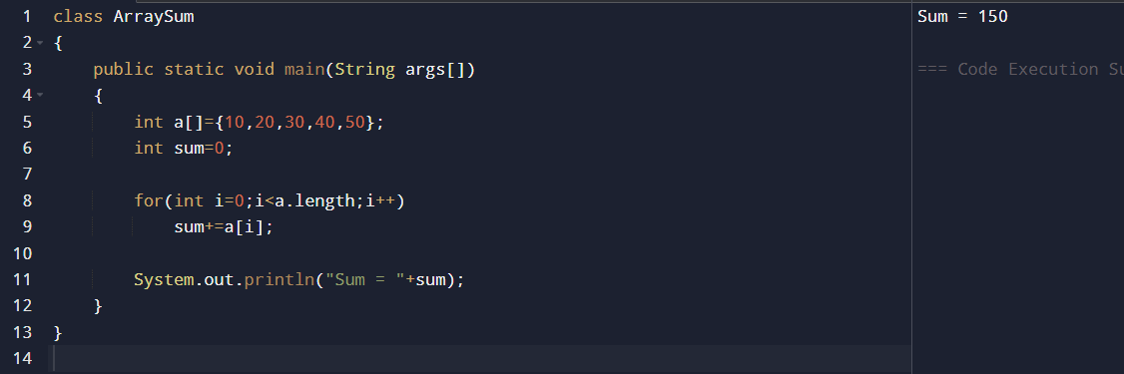
Program 2: Average of Array Elements
class ArrayAverage
{
public static void main(String args[])
{
int a[]={10,20,30,40,50};
int sum=0;
for(int i=0;i<a.length;i++)
sum+=a[i];
double avg=(double)sum/a.length;

System.out.println("Average = "+avg);
}
}
Output
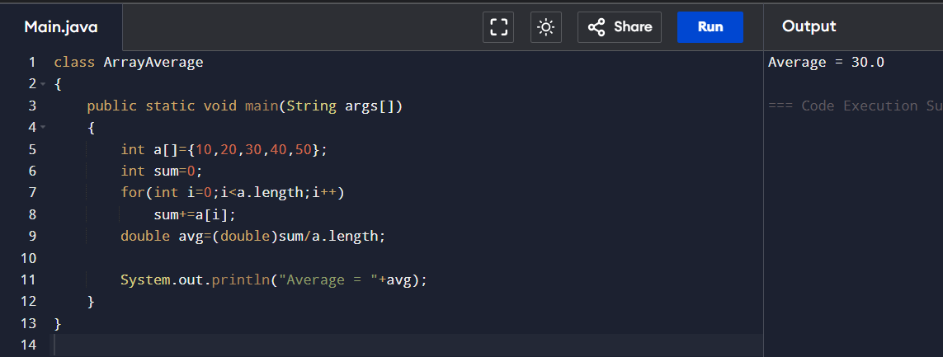
Program 3: Reverse an Array
class ReverseArray
{
public static void main(String args[])
{
int a[]={10,20,30,40,50};
System.out.println("Reversed Array:");
for(int i=a.length-1;i>=0;i--)
System.out.print(a[i]+" ");
}
}

Output
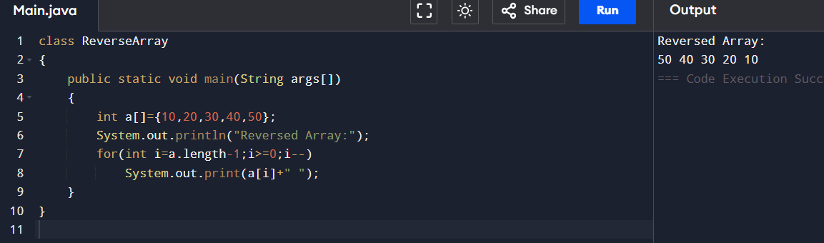
Program 4: Second Largest Element
class SecondLargest
{
public static void main(String args[])
{
int a[]={10,25,15,40,35};
int largest=Integer.MIN_VALUE;
int second=Integer.MIN_VALUE;
for(int i=0;i<a.length;i++)
{
if(a[i]>largest)
{
second=largest;
largest=a[i];
}
else if(a[i]>second && a[i]!=largest)
{
second=a[i];
}
}
System.out.println("Second Largest = "+second);
}
}

Output
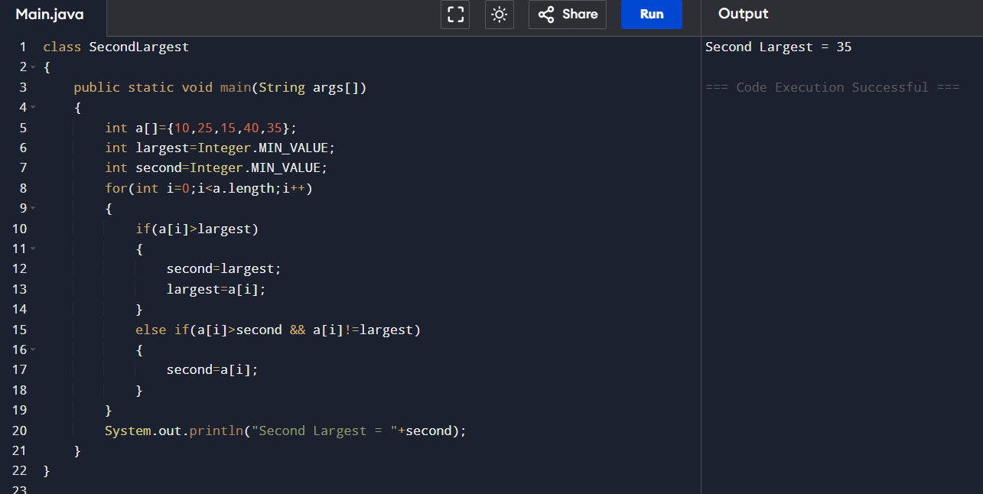
Result
Thus, the Java programs for array sum, average, reverse, and second-largest element were executed successfully.

